*Florida International University*

*School of Computing and Information Sciences*

CIS 4911 - Senior Capstone Project

Software Engineering Focus

Feature Document

User Story # 595

**Team Member:**

Garrett Lemieux

**Product Owner(s)**:

Francisco Ortega

**Mentor(s)**:

Francisco Ortega

**Instructor**: Masoud Sadjadi

**User Story - Change Line Size and Change Color of Line**

* As a User I would like to be able to have the same functionality as the multi touch device when drawing lines with leap motion in order to allow for diverse images to be created with leap motion.
* Acceptance Criteria:

1. Be able to draw different size lines.
2. Be able to change color of lines.
3. Leap motion and multi touch must have same functionality.

**Use Case: User wants same functionality as multitouch**

User wants to change the size of line or color of line being drawn with leap motion.

* Details:
* Actor:
  + User
* Pre-conditions:
  + TouchPointApp is running.
  + Leap motion drawing is enabled
* Description:
  + Use case begins when User has decided to change the size of the line or color of the line to be drawn when using leap motion.
  + User can press ‘z’ to decrease size of drawn line or ‘x’ to increase the size of the drawn line.
  + User can press ‘q’ or ‘w’ to cycle through colors or ‘r’ to change color of line to random colors.
  + Use case ends once the user finishes painting a line and the line is a different size or different color.
* Post-conditions:
  + The size of the line drawn by user has changed depending on chosen key or color of line has changed depending on chosen key.
* Alternative Courses of Action:
  + User can decrease the size of line painted by pressing ‘z’ key.
  + User can increase the size of line painted by pressing ‘x’ key.
  + User can cycle forward through possible color of lines by pressing ‘w’ key.
  + User can cycle forward through possible color of lines by pressing ‘q’ key.
  + User can change color of line to a random color by pressing ‘r’ key.
* Decision Support:
  + Frequency: High, User will need to vary his or her lines and color of lines to create unique paintings.
  + Criticality: High, Allows Users to depict different designs with varied sized and colored lines.
  + Risk: Low, Had the varied line function and varied color functions created for multitouch need to make it work with leap motion implementation.
* Constraints:
* Usability:
  + Need to be able to read user guide and follow instructions
* Reliability
  + High
* Performance
  + Performance: High
  + Failure: Low
* Supportability
  + Multi-touch Screen (ACER)
  + Leap Motion Device
* Modification History:
  + Owner: Garrett Lemieux
  + Initiation Date 02/15/2016
  + Date last Modified: 05/2/2016

**Use Case Diagram**

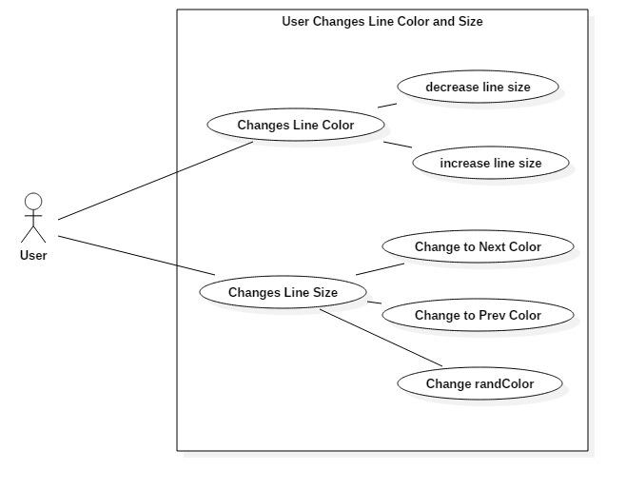

**Sequence Diagram**

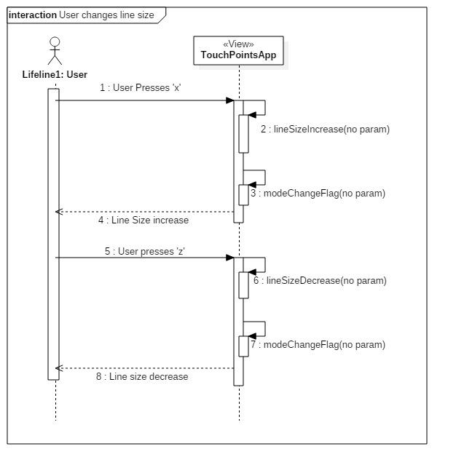

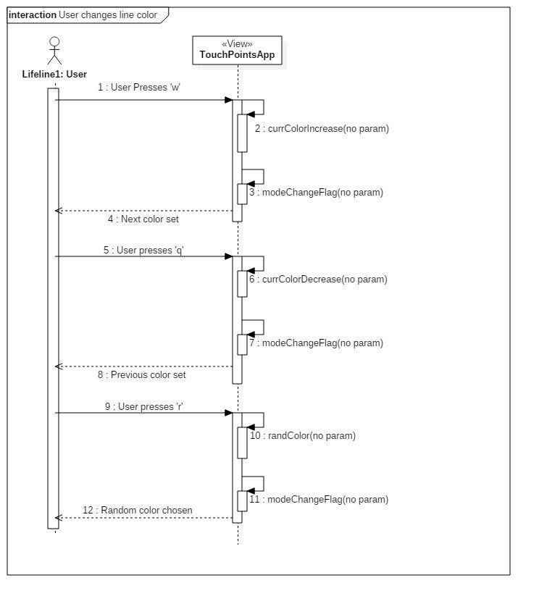

**Class Diagram**

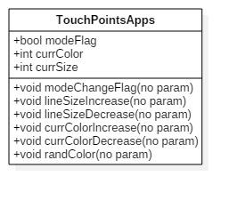

**Unit Test**

* Sunny Day Test:
  + Test Case  - User wants to increase line size the
    - Test Purpose: Test if line size is increased.
    - Test Procedure: User starts application. Users draw line with default size and the presses ‘x’ key once draws a second line and presses ‘x’ a third time. Then observes results.
    - Expected Results: User should three lines drawn smallest starting from left and largest on the right.
  + Test Case  - User wants to decrease line size the
    - Test Purpose: Test if line size is decreased.
    - Test Procedure: User starts application. Users draw line with default size and the presses ‘z’ key once draws a second line and presses ‘x’ a third time. Then observes results.
    - Expected Results: User should three lines drawn largest starting from left and smallest on the right.
  + Test Case  - User wants to change to next color and prev color
    - Test Purpose: Test if line color can be changed to next color.
    - Test Procedure: User starts application. Users draw line with default color and the presses ‘w’ key once draws a second line and presses ‘q’ a third time. Then observes results.
    - Expected Results: User should three lines first line default color and then second color should be different and third color should be default color.

.

* Rainy Day Test:
  + N/a

**Integration Testing**

* The ability to change the line color and line size works in TouchPointsApp.cpp
* Both devices can draw with new color and line size when draw setting has changed using keyboards.
* ** Note this feature is obsolete Now**

**User Guide**

* Since feature is obsolete and won’t be provided to user the guide was removed.